Applicator Spray for BOARBETTER

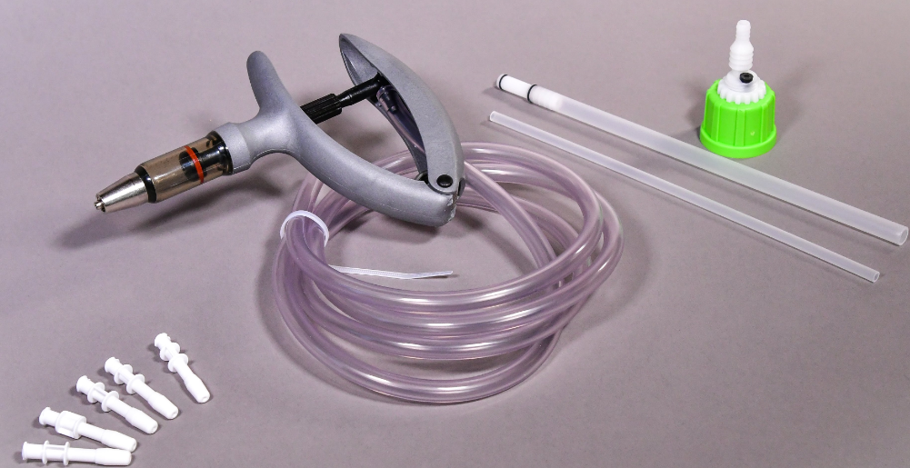
Product Information
1 kit composed of:
- 1 syringe 2mL + tube
- 1 cap + 2 tube
- 5 nozzle spray

 | Product Information | Number Article | List price
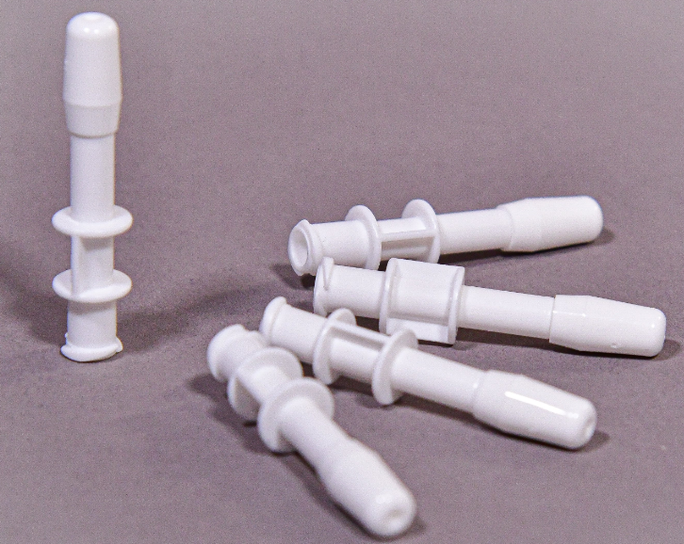 | NOZZLE SPRAY:  Bag of 100 nozzles
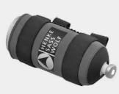 | Bottle Holder  Belt model for 1 L bottles x1

